Using JBuilder with Borland servers
This chapter explains how to set up and use Borland servers with JBuilder. JBuilder supports the Borland Enterprise Server AppServer Edition 5.2.1.
To configure JBuilder to target Borland Enterprise Server AppServer Edition 5.2.1,
- Choose Tools|Configure Servers to display the Configure Servers dialog box.
- Select Borland Enterprise Server AppServer Edition 5.2.1 from the User Home folder in the left pane.
The right side of the dialog box displays the default settings for the server. The General page has fields that all servers have in common, while the Custom page has fields that are specific to the selected server. In some cases, modifying a Custom setting will update a setting on the General page.
- Select the Enable Server option at the top of the dialog box.
Checking this option enables the fields for the selected application server. You won't be able to edit any fields until it is checked. The Enable Server check box also determines whether this server will appear in the list of servers when you select a server for your project using Project|Project Properties|Servers.
- Check the General tab to view and change (if required) default directories and parameter settings for the server. If JBuilder's default settings are not appropriate, edit any of the settings as needed. To change settings, click the ellipsis (…) button next to the field and make your changes.
  - Home Directory: The directory where Borland Enterprise Server AppServer Edition 5.2.1 is installed. The default is: <drive>:/BES If the default directory is not accurate, use the ellipsis (…) button to browse the correct directory.
  - Native Executable Launcher: The native executable used to run this partition. The default is partition.exe in the Home Directory's bin folder.
  - VM Parameters: The parameters to pass to the virtual machine.
  - Server Parameters: The parameters to pass to the server. The default is: -server <server_name> -partition jbuilder
  - Working Directory: The name and location of a working directory.
The General tab will look similar to this:
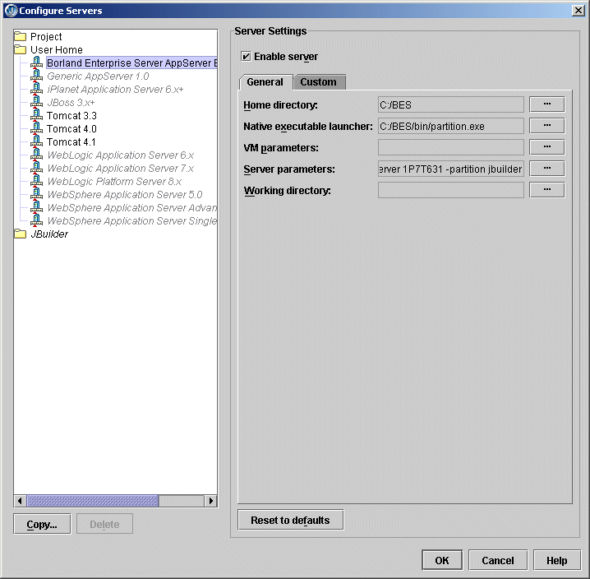
- Click the Custom tab to view and change (if required) fields unique to the server. Change or fill in these fields:
  - JDK Installation Directory: The directory where the JDK version required by the server is located. JBuilder fills this field in automatically, depending on the value you specified for the Home Directory on the General page. For the Borland Enterprise AppServer Edition 5.2.1, the directory is jdk/jdk1.4.1 directory in the Home Directory. Note that the the Borland Enterprise Server running on the Windows platform can use either JDK 1.3.1 or JDK 1.4.
  - Server Name: The name of the server you are configuring. By default, JBuilder specifies the identifier of your machine.
  - Partition Name: The name of the partition in which the server is run. For more information on partitions, see the "Partitions, partition services, and J2EE APIs" section in this chapter.
  - Add A Management Agent Item To The Tools Menu: Adds a Management Agent item to the JBuilder Tools menu, so you can start the Management Agent from within the JBuilder IDE.
  - Add A SonicMQ Broker Agent Item To The Tools Menu: Adds the SonicMQ Broker Agent item to the JBuilder Tools menu, so you can start the SonicMQ Broker Agent from within the JBuilder IDE.
  - Server Realm: The realm of the server. For more information about the server realm, see your Borland Enterprise Server documentation.
  - User Name: The name you use to identify yourself to the server. The default value is admin.
  - User Password: The password you use to identify yourself to the server. The default fault is admin.
  - Advanced Settings: Click this button to display the Advanced Settings dialog box. Use this dialog box to change the number of the port used by the Management Agent and to select the Use Security option. The management port is used in JBuilder to detect the server during startup and deployment. Change the management port only if you are deploying to a remote server with a management port that is different from the default. When you change the port number, please ensure that you entered the correct port number as configured in the server, as the server won't start up without the correct port number. The port and security settings you choose must match the settings of your server. JBuilder updates the values in this dialog box whenever the Home Directory changes. The initial values are read from the Borland Enterprise Server property files.
The Custom tab will look similar to this:
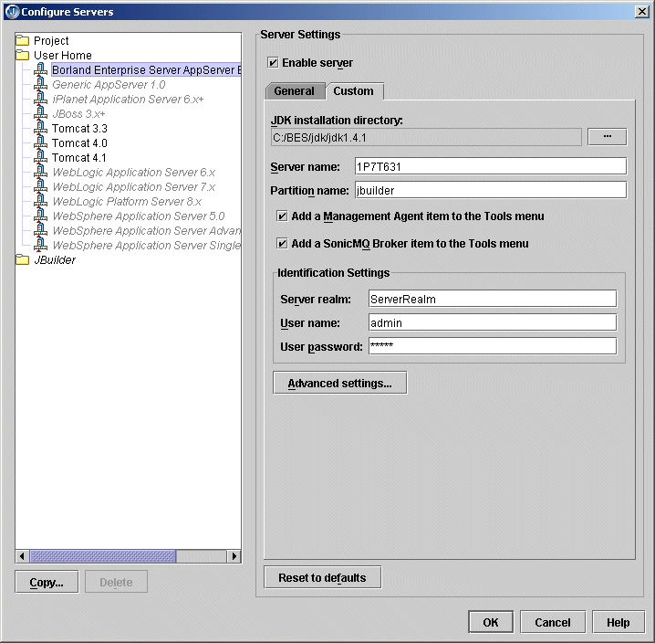

Making the ORB available to JBuilder
You use the CORBA node of the Enterprise Setup dialog box (Tools|Enterprise Setup) to set up the Borland Enterprise Server AppServer Edition 5.2.1 for use with VisiBroker. For Borland Enterprise Server AppServer Edition 5.2.1, the server will create its own VisiBroker configuration called "VisiBroker (Borland Enterprise Server AppServer Edition 5.2.1)." The default VisiBroker configuration won't be changed.
You also use this dialog box to set the VisiBroker Smart Agent port to a unique number. All client/server communication takes through the Smart Agent port. To start the Smart Agent from the Tools menu, check the Add The VisiBroker Smart Agent Item To The Tools Menu option. This option is selected by default. The CORBA node of the Enterprise Setup dialog box looks like this:
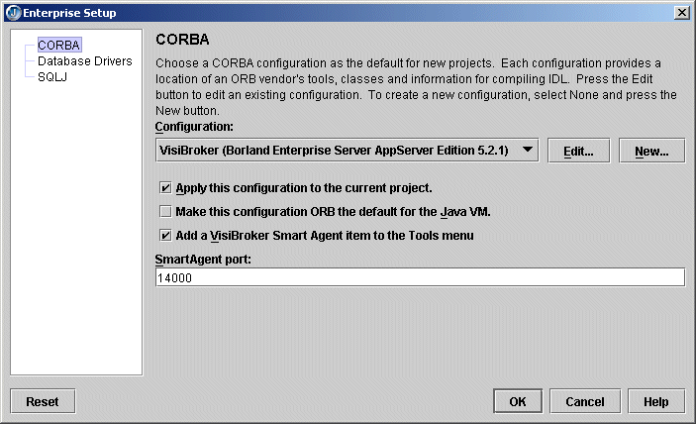
To make the ORB available to JBuilder, you must start the VisiBroker Smart Agent with the Tools|VisiBroker Smart Agent command. This handles the initial bootstrap issues such as how the client locates the naming service and so on.
When you start the Management Agent with the Tools|Borland Enterprise Server Management Agent command, the VisiBroker Smart Agent is started as part of the process. Always start the Borland Enterprise Server Management Agent instead of the VisiBroker Smart Agent. If you don't start it, it is automatically started for you when you start the server within JBuilder. Note that starting the server automatically might take longer because the server searches for any running agents. The most efficient way to start the Management Agent is to start it yourself.
For more information on setting up the ORB for use within JBuilder, see "Setting up JBuilder for CORBA applications."

Partitions, partition services, and J2EE APIs
In the Borland Enterprise Server AppServer Edition 5.2.1, a server (a machine identifier) manages a single partition or multiple partitions. Because each partition is a separate process, an application's functions can be distributed across multiple processes. When you use the Configure Servers dialog box (Tools|Configure Servers) to configure the server, all these pieces are seamlessly set up for use in JBuilder. For more information on the Borland Enterprise Server architecture, refer to the documentation, available from the Help menu of the Borland Management Console.
Partitions provide containers and services for hosting your applications. Any or all of a partition's containers and services can be enabled or disabled. Additionally, a partition can be cloned (copied) on the same configuration or server or on another enterprise configuration or server located on the same local area network. Cloning a partition can save significant time in the deployment process because it not only copies all of the deployed modules, but also copies all the associated service configurations settings which can require a considerable amount of time and effort to complete.
Application components are hosted in either the web container or EJB container, or simply in the partition itself (in the case of connectors). You can deploy application EARs or smaller archives to partitions. The partitions are "smart" and will place your application components in the proper containers. Since you may create as many partitions as you wish, you can also have as many container instances as you wish. Borland provides up to two different containers per partition instance:
- Web container (Tomcat 4.0): for hosting JSPs and servlets, and
- EJB container (Borland): for hosting EJB components
Note: You don't need to start Tomcat separately.
Each partition also provides Partition Services and J2EE APIs as Partition Services. These services and APIs are:
- Naming Service: In Borland Enterprise Server, the Naming Service is managed by the VisiBroker ORB
- JDataStore: Borland's all-Java database
- JDBC: For getting connections to and modeling data from databases
- Java Mail: A Java email service
- JTA: The Java transactional API
- JAXP: The Java API for XML parsing
- JNDI: The Java Naming and Directory interface
- RMI-IIOP: Remote method invocation (RMI) carried out via internet inter-ORB protocol (IIOP)
Note: The ports used for the Tomcat and JDataStore services must be unique. The default settings will not cause a conflict.
For the Borland Enterprise Server AppServer Edition 5.2.1 running inside JBuilder, the partition name is jbuilder. This partition is created the first time you run the server from JBuilder. You can start multiple partitions using multiple JBuilder run configurations. To create multiple run configurations, follow these steps:
- Choose Run|Configurations, then click New.
- Enter a name for the configuration in the Name field.
- Change the Run Type to Server. The displayed server is the server selected for the project in Project Properties|Server.
- Edit the Server Command Line parameters and change the Server Parameters to the server and partition you want to use, as show in the following figure:
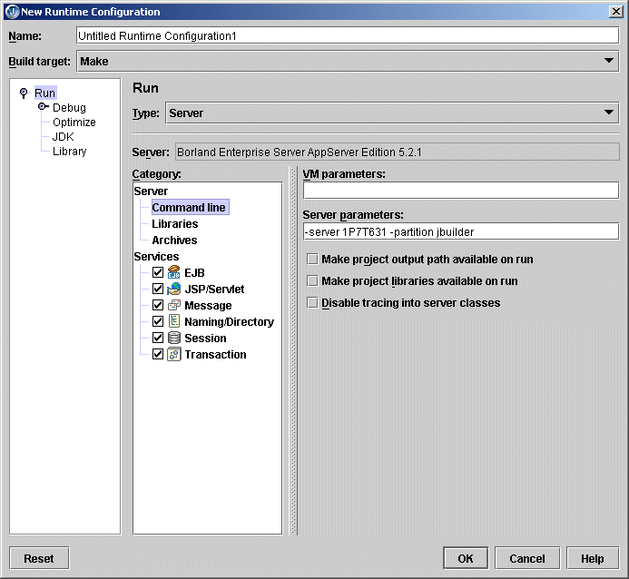
- Click OK to close the New Runtime Configuration dialog box and save the configuration.
- Repeat these steps to create additional run configurations to run other partitions.
Before starting the partition, ensure that you have the naming service enabled for only one of the partitions to avoid naming service conflicts. To disable the naming service for a partition, edit the run configuration for the partition (Edit Runtime Configuration dialog box) and uncheck the naming service option, as shown in the following figure:
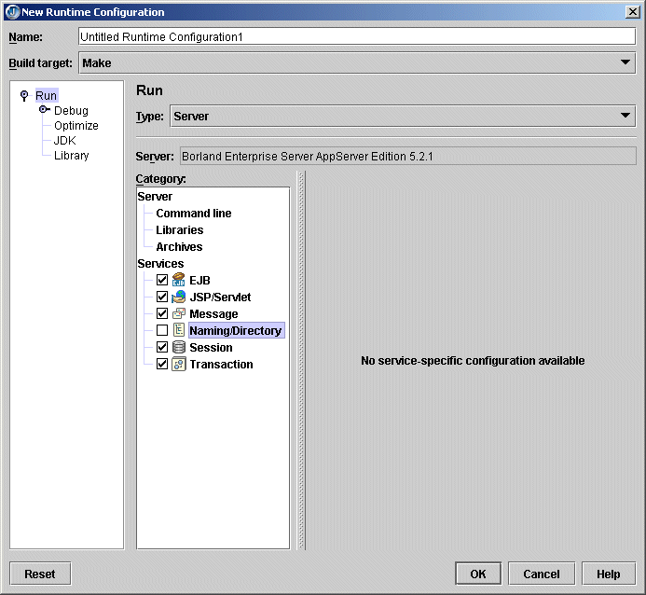

Changing the management port
The management agent manages all partitions. The default management port, set on the Advanced Settings dialog box for Borland Enterprise Server AppServer Edition 5.2.1, is 42424. If 42424 is already in use, you can change the management port used by JBuilder, or the one used by the server.
To change the port used by JBuilder,
- Choose Tools|Configure Server and chose Borland Enterprise Server AppServer Edition 5.2.1 from the User Home Folder on the left.
- Click the Custom tab, then the Advanced Settings button.
- Change the port in the Management Port field, as shown in the following figure:
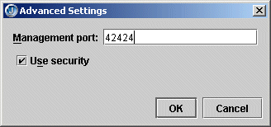
- Click OK two times.
To change the management port used by the server,
- Open the Borland Management Console.
- Double-click Installations.
- Right-click the server you want to change the port for.
- Select Update Ports from the context menu.
- Use the Port Configuration wizard to change the Management Port number. The User Port value is equal to the Smart Agent Port in JBuilder.

Starting the server
Before any server related actions (server startup, deployment, and so on) are performed, you must start the management agent with Tools|Borland Enterprise Server Management Agent. This starts a server process (ias), the management os agent, the CORBA os agent and the default standard partition. If you stop the default partition, you won't have any conflicts with any other partitions started in JBuilder. (You can stop the default partition from the Borland Management Console.)
After the management agent has started up, you can launch the partition by right-clicking the EJB or web module in the project pane and selecting Run Using Defaults. You can also create a Server run configuration and run the project using that configuration.
Running the partition in JBuilder will:
- Create the partition, if not already present. The partition name used in this step is derived from the run configuration used to startup the server. If you are starting the configuration or server using the default configuration, the partition name as configured in the application server properties will be used.
- Deploy any resources defined in jndi-definitions.xml (if present) to the root of the partition directory. For the Borland Enterprise Server AppServer Edition 5.2.1, this directory is: APPSERVER_HOME\var\servers\SERVER_NAME\partitions\PARTITION_NAME\.
This file will be created if your project contains an EJB 2.0 module with data sources/messaging resources defined.
Note: This action can be turned off by unchecking the Deploy jndi-definitions.xml option in the Deployment EJBs Services properties on the Server node of the Project Properties dialog box.
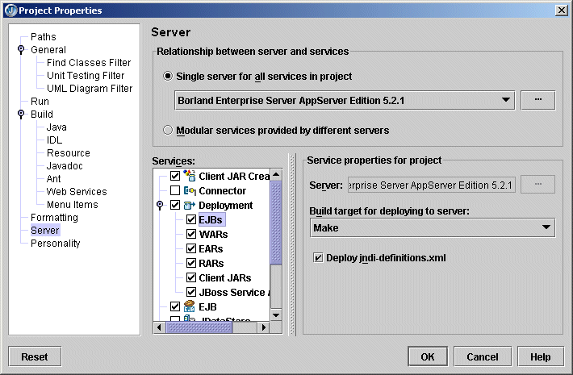
- Copy selected libraries to the partition's lib directory. All archives in this directory will be added to the partition's classpath when the partition is started up.
For the Borland Enterprise Server AppServer Edition 5.2.1, the directory is APPSERVER_HOME\var\servers\SERVER_NAME\partitions\PARTITION_NAME\lib.
The libraries to be copied can be set with the Libraries To Deploy At Runtime list on the Edit Runtime Configuration dialog box for the server run configuration:
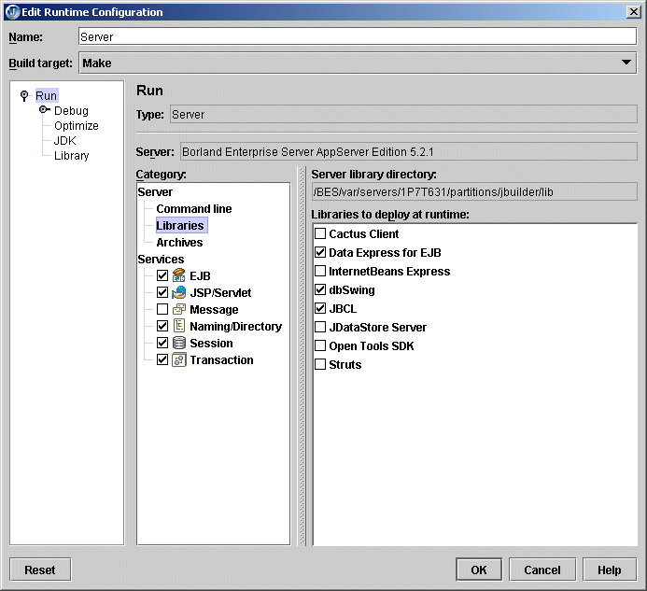
- Remove any archives deployed to the partition, if this option is selected. This can be set from the Archives Server category on the Edit Runtime Configuration dialog box for the server run configuration. If you want to have a clean partition, select the Remove Archives Already Deployed To Server option.
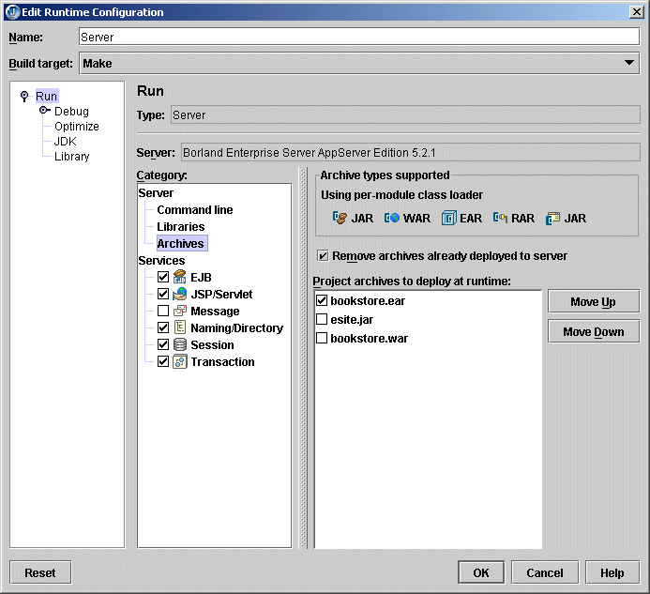
- Deploy archives if selected. By default all deployable archives in the project are selected. To change this, click the Archives Server category in the Server run configuration (Edit Runtime Configuration dialog box) and unselect any archives that you do not wish to deploy.
- Start the partition. When partition startup is complete, you should see the message "Partition <PARTITION_NAME> has been started." Archives deployed at startup should be loaded and accessible.
Note: By default, all services associated with a partition are started. This could cause the partition to take a longer time to start. To reduce startup time, uncheck the services that you don't require in the Server run configuration.

Remote deploying
To prepare to remote deploy EJBs, WARs, and EAR modules for the Borland Enterprise Server AppServer Edition 5.2.1, follow these steps.
- Choose Tools|Configure Servers.
- Select Borland Enterprise AppServer Edition 5.2.1 from the left side of the dialog box.
- Click the Custom tab and set the Server and Partition names to match that of the remote server.
- Click Advanced Settings and make sure the Management Port matches your server configuration.
- Click OK two times.
- Choose Tools|Enterprise Setup.
- Select the CORBA node to display the CORBA page, and set the Smart Agent Port to match that of your server configuration.
- Click OK.
Now you are ready to deploy. There are two ways to deploy EJBs, WARs, and EAR modules using JBuilder:
- Deploying to the server using the Borland Enterprise Server Deployment Wizard (Tools|Server Deployment). This is a Borland Enterprise Server tool that requires that the management agent is running. On the first page of the wizard, select the modules to deploy. The wizard then detects all partitions on the server, even if they have not been started. Select the appropriate partition from the list and click Finish to deploy the archive. If the partition is already running, restart it to access the deployed archive.
- Deploying to the server using the context menu option on any deployable node. Right-click the deployable node, choose Deploy Options, then Deploy. You can also select multiple deployable nodes, right-click them, and use the context menu that appears to deploy more than one module.

Remote debugging
Before you can debug your application remotely, you need to configure the partition. You can do this before you start the server or while the server and partition are already running. Choose one of these topics for more information:
- "Setting up for remote debugging before the Borland Enterprise Server AppServer Edition 5.2.1 is running"
- "Setting up for remote debugging when the Borland Enterprise Server AppServer Edition 5.2.1 is already running"
Once the configuration is complete and the server and partition are started, follow the instructions in the "Remote debugging in JBuilder" section.
For a tutorial that walks you through this process using the Borland Enterprise Server AppServer Edition 5.2.1, see Tutorial: Remote debugging with the Borland Enterprise Server AppServer Edition 5.2.1 in Developing Applications with Enterprise JavaBeans

Setting up for remote debugging before the Borland Enterprise Server AppServer Edition 5.2.1 is running
To set up for remote debugging before you start the Borland Enterprise Server AppServer Edition 5.2.1,
- Start the Borland Management Console.
- Click the Installations button.
- Locate the server you will start. Expand the node and locate the partition you want to debug in JBuilder. (Typically, this is the jbuilder partition.)
- Click the partition node in the structure pane.
- Search for and set the debug parameters as follows in the content pane (set the values that are in bold-faced type):

- partition.enable_jpda_debug=true
- partition.jpda.transport_address=3999
- partition.jpda.suspend=false
- Click Apply Changes.

Setting up for remote debugging when the Borland Enterprise Server AppServer Edition 5.2.1 is already running
To set up for remote debugging when the Borland Enterprise Server AppServer Edition 5.2.1 is already running,
- Start the Borland Management Console.
- Click the Servers button.
- Expand the Enterprise Servers node and locate the partition you want to debug. (Typically, this is the jbuilder partition.)
- Right-click and select Configure.
- Choose the JPDA tab.
- Check the Enable JPDA Remote Debugging option.
- Set the Transport Address field to 3999.
- Uncheck the Suspend Partition Until Debugger Attaches option.
- Click Apply Changes.

Remote debugging in JBuilder
Once the server and partition have been started, follow these steps from within JBuilder:
- In the project from which you want to launch the remote debug session, choose Run|Configurations.
  - If you have not yet created a server type run configuration, click New. In the New Runtime Configuration dialog box, set the Type to Server.
  - If you have already created a server run configuration, select it and choose Edit.
- Select the Debug node.
- Check the Enable Remote Debugging option.
- Select the Attach option.
- Enter the name of the machine on which the server is running in the Host Name field.
- Make sure the Transport Type is set to dt_socket and the Address is set to 3999. The dialog box will look similar to this:
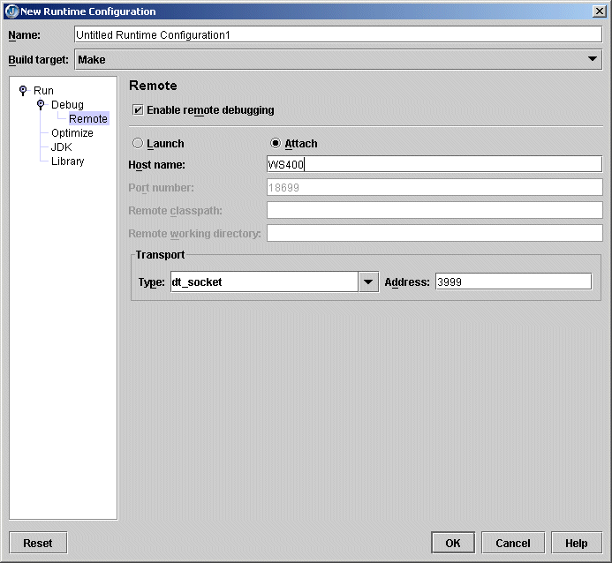
- Click OK to close the dialog box.
- Set a breakpoint in the process you want to debug.
- Deploy that process to the running partition.
- Click the down arrow next to the Debug Project button on the toolbar and select the server configuration you just created or edited. The debugger launches, attaches to the partition running remotely, and stops at the breakpoint.

Web module workarounds
The default application server install includes ROOT.war, which contains the default context. If you deploy an EAR that contains a default context, you must delete ROOT.war (or rename its extension) so that it does not load and cause a conflict. If deploying WARs (with the container classloader policy), the resulting WAR is automatically copied to the partition as ROOT.war, in which case there is no conflict. Please note that it is the <context-root>!ROOT!</context-root> element in the web-borland.xml file that designates the context as root, not the file name.
If you are working on a named context but have the root context in an already deployed archive, the internal web browser in JBuilder will attempt to load once that archive is loaded by the container, because the root context can potentially match any URL. You'll then probably get a "Document not found" error. To prevent this, remove ROOT.war if you're not using it or overwriting it.

International issues
Japanese characters in the JNDI name are supported by the Borland Enterprise Server AppServer Edition 5.2.1.

